Respectable Sins
Session Fifteen
Worldliness & Where Do We Go From Here

Hook
- Have you begun to be more aware of envy and jealousy in your life?
- How are you responding when you see these attitudes and sins become apparent?
Book
- What is worldliness?

- How does 1 John 2:15-16 help us to understand about what the bible means when it refers to the sin of worldliness?

- How would the Amish define worldliness?

- How would some conservative, legalistic churches define worldliness?

- Is this what John had in mind when he wrote 1 John 2:15-16? Read the verses again.

- How does 1 Corinthians 7:29-31 help us understand the sin of worldliness?

- What is worldliness then?

- How does Colossians 3:1-2 help us with this problem?

- What is worldliness again?

The Bible defines worldliness by centering morality where we intuitively know it should be. Worldliness is the lust of the flesh (a passion for sensual satisfaction), the lust of the eyes (an inordinate desire for the finer things of life), and the pride of life (self-satisfaction in who we are, what we have, and what we have done). Worldliness, then, is a preoccupation with ease and affluence. It elevates creature comfort to the point of idolatry; large salaries and comfortable life-styles become necessities of life.
Worldliness is reading magazines about people who live hedonistic lives and spend too much money on themselves and wanting to be like them. But more importantly, worldliness is simply pride and selfishness in disguises. It's being resentful when someone snubs us or patronizes us or shows off. It means smarting under every slight, challenging every word spoken against us, cringing when another is preferred before us. Worldliness is harboring grudges, nursing grievance, and wallowing in self-pity. These are the ways in which we are most like the world.
Dave Roper, The Strength of a Man, quoted in Family Survival in the American Jungle, Steve Farrar, 1991, Multnomah Press, p. 68.

Money
America is one the wealthiest countries in the world. But the way we handle our money is, as Bridges puts it, “scandalous.” Consider the following stats taken from Barna Research Group.
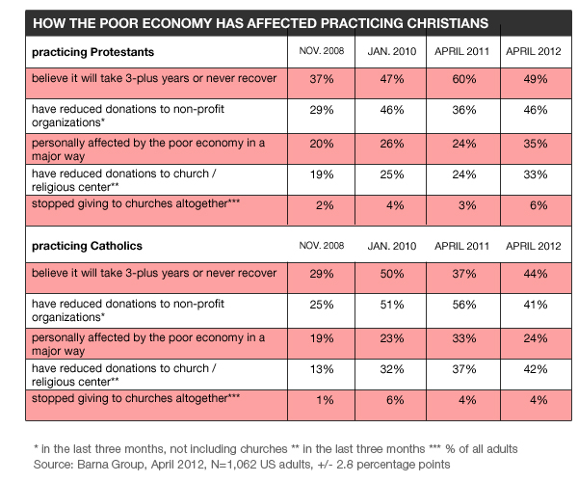
- A natural question at this juncture is, how much should we be giving? What is the biblical mandate for our giving?
  - OT
    - Genesis 14:20

  - NT
    - 1Co 16:2
    - 2Co 8:

  - What do the following verses reveal about tithing?
    - Mal 3:8
    - Mat 6:3
    - Mat 6:4
    - 1Ti 6:10

- When we give less than what scripture indicates we should give, what does that make us?

- Bridges says, “If money wins out in our lives, it is not God but we who lose. Ultimately, God does not need our money. If we spend it on ourselves, it is we who becomes spiritual paupers.” In what ways in this true?

- Some Christians think they cannot afford to give 10% of their income to God’s work. How does 1 Kings 17:8-16 speak to this?

- How does 2 Corinthians 8:9 help us in learning how to view our money biblically?

Immorality
As we move into this area of discussion, you may be wondering by Bridges includes this because, for most, we understand that the sin of pornography, adultery, and immorality are clearly wrong and few, if any, would consider it a respectable sin. So why is it included here? It is included because we can and do tolerate immorality in what we are going to call “vicarious immorality.”
- What do we mean when we say, “vicarious immorality?”

- In what ways do we participate in “vicarious immorality?”

- How does 1 Timothy 2:9 help give guidelines for modest dress?

- How does Proverbs 27:20 equip us for facing the temptations we will encounter in a sinful and ungodly world?

- How does Romans 6:21 act as a second line of defense?

Idolatry
- What do we mean when we talk about the sin of idolatry?

- To what kinds of idols are we referring?

- How does 2 Corinthians 5:9 help us combat idols of the heart we face?

- How do we confront and battle political and cultural issues that affect scripture without making idols out of them?

- Let’s come back to the twofold definition of worldliness. First, it is a preoccupation with the things of this temporal life. Second, it is accepting and going along with the values and practices of society around us without discerning if they are biblical. The key is in the two words, going along.” This is why we go along with immodest dress, sports preoccupation, a sinful competitive spirit, etc without giving thought to whether these are sinful or not. They do not seem sinful outright, so we assume it is ok and that there is nothing wrong with it. We need to be a people who evaluate all things in light of scripture and who do NOT become preoccupied with the things of this life or simply GO ALONG with the world because it is not outright sin.
- The world's smiles are more dangerous that its frowns. Source Unknown.
- How then, can we deal with our tendencies toward worldliness?

Look
Where do we go from here?
- How do we develop a deeper affection for God?
  - Increase your awareness of our still-remaining sinfulness and of Christ’s love for us in dying for that sin.
  - We need to remember who we once were and who we are now by the grace of God.
  - This is one of the biggest reasons I love the Puritan Prayers I read on Sunday mornings and why I found them important enough to read. They were keenly aware of their own sinfulness and the grace of God that rescued them from sin and death and it changed their lives. We have largely forgotten our sin and the depth of its depravity and therefore have lost the affection of God for our salvation because it is not as great in our minds as it is in reality.
  - Luke 7:36-50
  - We need to grow in our awareness of Christ’s love for us revealed in the gospel. When we have become aware of this, this love will constrain us (2 Corinthians 5:14-15) and propel us to love God more and seek his glory as the end goal of our lives.
  - We need to PRAY over these respectable sins and identify which ones are present in our lives, to what degree they are present, repent of those sins, and allow God to progressively work in our lives, removing them from us.
  - Ask others who know us well, who would be godly and humble about it, to help reveal to us areas of our life we need to repent of and work on.

Took
- Prayerfully ask God to reveal areas of your life that you need to repent of “respectable sins.”
- Repent of these sins.
- Seek accountability and support in the journey of sanctification.
- Seek to bring all thinking and desires in line with scripture and seek to please God in all you do.
- Remember who you once were and who God has made you to be.
- Make it your goal and intent to increase your love for God and consider how your life can and should be different as a result.

