Judges 17-18

Introduction:

To worship God is to recognize his worth or worthiness; to look God-ward, and to acknowledge in all appropriate ways the value of what we see. The Bible calls this activity "glorifying God" or "giving glory to God," and views it as the ultimate end, and from one point of view, the whole duty of man (Ps. 29:2; 96:6; 1 Cor. 10:31).

Scripture views the glorifying of God as a sixfold activity:
praising God for all that he is and all his achievements;
thanking him for his gifts and his goodness to us;
asking him to meet our own and others' needs;
offering him our gifts, our service, and ourselves;
learning of him from his word, read and preached, and obeying his voice;
telling others of his worth, both by public confession and testimony to what he has done for us.

Thus we might say that the basic formulas of worship are these: "Lord, you are wonderful"; "Thank you, Lord"; "Please Lord"; "Take this, Lord"; "Yes, Lord"; "Listen everybody!"

This then is worship in its largest sense: petition as well as praise, preaching as well as prayer, hearing as well as speaking, actions as well as words, obeying as well as offering, loving people as well as loving God. However, the primary acts of worship are those which focus on God directly -- and we must not imagine that work for God in the world is a substitute for direct fellowship with him in praise and prayer and devotion.

James Packer, Your Father Loves You, Harold Shaw Publishers, July 1986, P. 15.

And perhaps this is where Israel went wrong. The did LOTS of things for God but they lost their fellowship with God.

Though they were created to worship and enjoy him, He became someone to obey rather than to love.

Love inspires obedience. Obedience does not produce love.

For Israel, they have been walking a path of apathy, apostasy, and (as we will see today) anarchy. They have been walking down a path that is progressing away from God, not towards Him.

What we need to learn today is simply this….

We were made to worship…so worship…God.

Skip to sermon

Outline:

Big Idea: You were made to worship…so worship….God.
- Apathy (1-2)
- Apostasy (3-16)
- Anarchy (17-21)
  - Idolatry (17–18)
    - Micah’s Idol - 17:1-6
    - Micah’s Priest – 17:7-12
    - Dan’s Territory – 18:1-10
    - Dan’s Theft – 18:11-26
    - Dan’s City – 18:27-31

Sermon Body

Our worshipping hearts are not the problem. The problem is when the object of that worship is the wrong thing.

Judges 17-21 reveal the anarchy that ensues when God is no longer the object of worship.

As we work through these passages, we will read the text as we go since it is lengthy text.

Big Idea: You were made to worship….so worship….God.
- Apathy (1-2)
- Apostasy (3-16)
- Anarchy (17–21)
  - As we move into these chapters, it is important to note that these final chapters form the epilogue of the book. In fact, like the double, parallel introductions, we see a similar pattern for the conclusions. 17-18 form one epilogue of the book and 19-21 form the second.
  - There has been some debate over the years about whether these final chapters belonged with the book, were original to the book, and who the author is. Some believe they were written by a different person than the rest of the book.
  - After much study and research, ultimately most conclude that though these final chapters have a different tone and feel, though they take a different approach it is strongly believed they are original to the text and that it concludes the book, tying themes and elements together, showing the ultimate and dismal state that Israel slumps to.
One commentator notes about these final chapters…
Judges disappear in the final five chapters of the book of Judges. So does divine deliverance. Names of all types of leaders virtually disappear. The emphasis turns to the lack of a king and the loss of national morality. Violence escalates. A tribe cedes its land and finds a new domicile in northern territory Joshua did not allot to any of the tribes. Another tribe sees some of its members commit a vile act violating all rules of hospitality, leading to the first true gathering of all the tribes of Israel in the entire book. All Israel then fights together, but the enemy is a tribe of Israel. Wong remarks, “The narratives seem full of inconsistencies, such that nearly all the main characters act in inexplicable ways and make decisions that appear self-contradictory and ‘bizarre.’ … Tucked away inconspicuously within almost every single one of these bizarre episodes is an echo of a specific event that took place in the life of a major judge in the central section of the book” (Compositional Strategy, 82–83).
Butler, T. C. (2009). Judges (Vol. 8, pp. 372–373). Nashville; Dallas; Mexico City; Rio De Janeiro; Beijing: Thomas Nelson.
Their step into bizarre and erratic behavior begins with a clear step into idolatry.
  - Idolatry (17–18)
    - Micah’s Idol - 17:1-6
Micah and the Levite
17 There was a man of the hill country of Ephraim, whose name was Micah. ² And he said to his mother, “The 1,100 pieces of silver that were taken from you, about which you uttered a curse, and also spoke it in my ears, behold, the silver is with me; I took it.” And his mother said, “Blessed be my son by the Lord.” ³ And he restored the 1,100 pieces of silver to his mother. And his mother said, “I dedicate the silver to the Lord from my hand for my son, to make a carved image and a metal image. Now therefore I will restore it to you.” ⁴ So when he restored the money to his mother, his mother took 200 pieces of silver and gave it to the silversmith, who made it into a carved image and a metal image. And it was in the house of Micah. ⁵ And the man Micah had a shrine, and he made an ephod and household gods, and ordained one of his sons, who became his priest. ⁶ In those days there was no king in Israel. Everyone did what was right in his own eyes.

The Holy Bible: English Standard Version. (2016). (Jdg 17:1–6). Wheaton, IL: Crossway Bibles.

      - Hill country of Ephraim

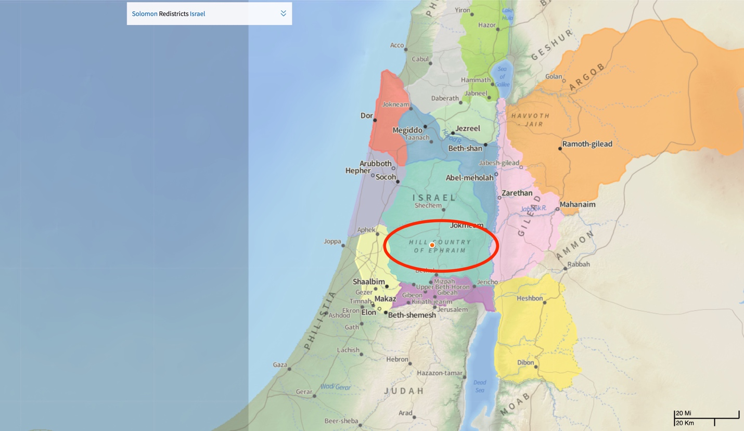

        - Plays a significant role final chapters of this book
        - Samuel’s family was from the Hill country of Ephraim (1 Sam 1:1)
        - Saul sought his donkeys there (1 Sam 9:4)
        - Saul hid from the Philistines there (1 Sam 14:22-23)
        - Sheba, who rebelled against David, was from here (2 Sam 20:21)
        - Solomon located an administrative district there (1 Kings 4:8)
        - Jeroboam I resided there in Shechem (1 Kings 12:25)
        - King Ahijah of Judah defiantly addressed Jeroboam I there (2 Chron 13:4)
        - This hill country of Ephraim is a place of fairly significant import.
      - Micah – Name means “who is like God”
        - Different than the prophet Micah
        - Not told much about him
      - Micah’s mother apparently had $1,100 pieces of silver stolen (An interesting figure considering the philistine lords each gave that amount to Delilah)
        - Some have looked for a deeper connection between Delilah and Micah because of this, but it is not likely.)
        - Not enough to make a clear connection.
        - Perhaps the author wanted us to see themes connecting Samson’s story and this one but there may no connection at all.
      - Micah confesses to the theft and returns it to his mother.
        - The curse she uttered seemingly being the motivation for doing so. He was afraid of it coming to pass.
        - At this point, Leviticus 6 tells us that he should have done two more things…pay restitution to his mother (1/5 of the principle balance-an additional 220 pieces.) and offer a sacrifice.
        - Neither of which happens. Again reminding us just how far the people have fallen. They either do not know or do not care about what the law expects of them.
      - She praises him, thanking God for him. What is absolutely intriguing is that the text uses the covenant name for Lord, Yahweh.
      - The wording and terminology suggests they are worshippers of Yahweh, but their actions violate any true understanding of what it means to worship Him.
      - She dedicates 200 pieces of that silver to be melted down and crafted into an idol.
        - There is debate about whether it is one or two items.
        - A carved image
        - A metal image
        - It is two items or two ways of describing the same object?
        - Our clue comes from verse 4

⁴ So when he restored the money to his mother, his mother took 200 pieces of silver and gave it to the silversmith, who made it into a carved image and a metal image. And it was in the house of Micah.
The Holy Bible: English Standard Version. (2016). (Jdg 17:4). Wheaton, IL: Crossway Bibles.

        - IT is singular. It speaks of this idol, using two descriptive ways to do so, but concludes the sentence with a singular form. Later on, it will be referenced again and it will seem to more clearly differentiate the two into two distinct items.
        - From verse 4 alone, we can conclude it was a single item described in two separate ways. Later when we see it, it is not quite so clear.
        - Whether it is one or two, does not really matter. They made an idol, an idol that was being dedicated to Yahweh in praise for the mother’s thief of a son returning the money to her for fear of her curse coming true.
        - Anyone else see the irony of this?
      - Micah then goes so far as to make an ephod and ordain his son as a priest.
      - Micah invents his own religion and idol worship.
        - Some have argued that this was not an idol but some sort of representation of Yahweh and his care for his people.
        - The writer of Judges, however, does not seem to share that sentiment.
      - We are reminded, in those days there was no king and they did what was right in their own eyes.
        - This was clearly a form of idolatry. Likely a blending of pagan idol worship with worship of Yahweh.
        - House gods are referenced in this text.
        - It seems that Israel has moved to considering Yahweh as just one of another gods and have blended worship of him with worship of these pagan gods of the land.
        - Before long, Micah gets himself a new priest, seemingly deposing his own son whom he appointed in that role.
    - Micah’s Priest – 17:7-12
⁷ Now there was a young man of Bethlehem in Judah, of the family of Judah, who was a Levite, and he sojourned there. ⁸ And the man departed from the town of Bethlehem in Judah to sojourn where he could find a place. And as he journeyed, he came to the hill country of Ephraim to the house of Micah. ⁹ And Micah said to him, “Where do you come from?” And he said to him, “I am a Levite of Bethlehem in Judah, and I am going to sojourn where I may find a place.” ¹⁰ And Micah said to him, “Stay with me, and be to me a father and a priest, and I will give you ten pieces of silver a year and a suit of clothes and your living.” And the Levite went in. ¹¹ And the Levite was content to dwell with the man, and the young man became to him like one of his sons. ¹² And Micah ordained the Levite, and the young man became his priest, and was in the house of Micah. ¹³ Then Micah said, “Now I know that the Lord will prosper me, because I have a Levite as priest.”
The Holy Bible: English Standard Version. (2016). (Jdg 17:7–13). Wheaton, IL: Crossway Bibles.
      - First time we see Levites show up in this book
        - Very intriguing
        - The religious, temple/tabernacle overseers, the spiritual leaders of the nation of Israel are absent for the majority of the book.
        - And when they do show up, we see them like this…
      - He is wandering, looking for a place to stay.
        - Not given a name here. Though 18:30 supplies it for us.
³⁰ And the people of Dan set up the carved image for themselves, and Jonathan the son of Gershom, son of Moses, and his sons were priests to the tribe of the Danites until the day of the captivity of the land. ³¹ So they set up Micah’s carved image that he made, as long as the house of God was at Shiloh.
The Holy Bible: English Standard Version. (2016). (Jdg 18:30–31). Wheaton, IL: Crossway Bibles.

        - Jonathan, so of Gershom, son of Moses.
        - Why was this Levite living in Bethlehem?
        - Bethlehem is not a Levitical town in Judah (Josh. 21:9–16)
        - Younger, K. L., Jr. (2002). Judges and Ruth (p. 338). Grand Rapids, MI: Zondervan.
        - Furthermore, since he was Gershonmite, that means means that he is a member of the Kohathite clan of the Levites, who were allotted ten towns in Ephraim, Dan, and Cisjordanian Manasseh (Josh. 21:5, 20–26).
Younger, K. L., Jr. (2002). Judges and Ruth (p. 339). Grand Rapids, MI: Zondervan.
        - He should not be have been living in Bethlehem.
        - Thus again, we see the people of Israel disregarding what God has established.
      - Comes across Micah’s home.
      - Micah entices him to stay with him and to serve as his priest. Offers to pay him 10 silver pieces a year, will give him a suit of clothes, and will provide for his living needs.
      - The man was content to accept this and so does.
        - We see this Levite being motivated by materialistic gain.
        - He accepts this offer here because it seems to appeal to him.
        - Later, we will see him accept a bigger and better offer from the tribe of Dan and he will leave Micah to pursue this better offer.
        - This later change would seem to validate for us that he is only after personal gain.
        - Everyone does what is “right” in his own eyes.
      - Micah then ordains this priest…devoted him to the work of priesthood
        - This ordaining of the Levite, most likely, demoted his own son, whom he had ordained as priest. But having an actual Levite would add a sense of prestige and blessing to his family religion that he did not formerly possess.
      - Micah’s see this as a sign of God’s blessing of him because now he has a Levite as priest as well. (Which means he probably knew that his own son was not a valid priest, but he ordained him anyway)
      - By the time we hit chapter 18, we shift focus to the tribe of Dan, but we don’t leave Micah and his priest behind.
    - Dan’s Territory – 18:1-10
Danites Take the Levite and the Idol
18 In those days there was no king in Israel. And in those days the tribe of the people of Dan was seeking for itself an inheritance to dwell in, for until then no inheritance among the tribes of Israel had fallen to them.
      - Dan had had the least success in driving out the natives of the land and claiming their inheritance.
      - Judges 1:34

³⁴ The Amorites pressed the people of Dan back into the hill country, for they did not allow them to come down to the plain.
The Holy Bible: English Standard Version. (2016). (Jdg 1:34). Wheaton, IL: Crossway Bibles.

      - We have a parallel here as well. Just as the Levite was looking for a place to dwell, so Dan was looking for a place to dwell.
² So the people of Dan sent five able men from the whole number of their tribe, from Zorah and from Eshtaol, to spy out the land and to explore it. And they said to them, “Go and explore the land.” And they came to the hill country of Ephraim, to the house of Micah, and lodged there.

      - So they sent out spies to explore the land.
      - From Zorah (connection to Samson) and Eshtaol.
      - One has to ask…if God has already determined the allotment of lands, why are searching? Shouldn’t they just be going and claiming the land that was given to them?
      - YES is the answer. But we know that they have not faithfully followed God or sought him.
      - They too, like the Levite come to the home of the Micah.

³ When they were by the house of Micah, they recognized the voice of the young Levite. And they turned aside and said to him, “Who brought you here? What are you doing in this place? What is your business here?” ⁴ And he said to them, “This is how Micah dealt with me: he has hired me, and I have become his priest.”

      - Their spies came by the house of Micah and they heard and recognized the voice of the Levite.
      - Possibly accent?
      - They pepper him with questions about why he is here, how he came to be here, and such.
      - He explains how he came to be employed by Micah.
      - They see an opportunity…

⁵ And they said to him, “Inquire of God, please, that we may know whether the journey on which we are setting out will succeed.” ⁶ And the priest said to them, “Go in peace. The journey on which you go is under the eye of the Lord.”

      - Now….why do they need to seek God’s direction again?
      - Hasn’t God told them what land is to be theirs? Didn’t God already promise that land to them?
      - They have what they need, but they have lost their way.
⁷ Then the five men departed and came to Laish

      - Map

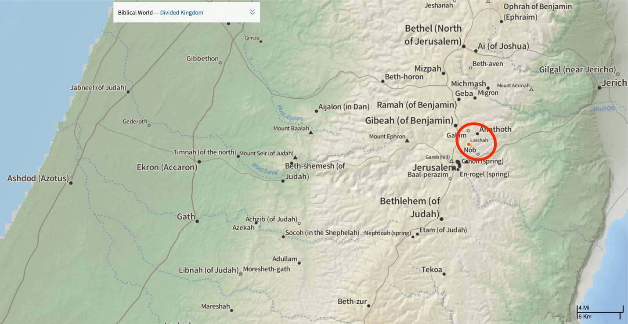

      - This is an inhabited city

and saw the people who were there, how they lived in security, after the manner of the Sidonians, quiet and unsuspecting, lacking nothing that is in the earth and possessing wealth, and how they were far from the Sidonians and had no dealings with anyone. ⁸ And when they came to their brothers at Zorah and Eshtaol, their brothers said to them, “What do you report?” ⁹ They said, “Arise, and let us go up against them, for we have seen the land, and behold, it is very good. And will you do nothing? Do not be slow to go, to enter in and possess the land. ¹⁰ As soon as you go, you will come to an unsuspecting people. The land is spacious, for God has given it into your hands, a place where there is no lack of anything that is in the earth.”

The Holy Bible: English Standard Version. (2016). (Jdg 18:1–10). Wheaton, IL: Crossway Bibles.

      - They report back a favorable report and declare that this land is good, the people unsuspecting, lets take the land of God has given it to us.
      - This, no doubt, was impacted by the Levite’s favorable response to them.
    - Dan’s Theft – 18:11-26
¹¹ So 600 men of the tribe of Dan, armed with weapons of war, set out from Zorah and Eshtaol, ¹² and went up and encamped at Kiriath-jearim in Judah. On this account that place is called Mahaneh-dan to this day; behold, it is west of Kiriath-jearim. ¹³ And they passed on from there to the hill country of Ephraim, and came to the house of Micah.

      - They encamped at Kiriath-Jearim
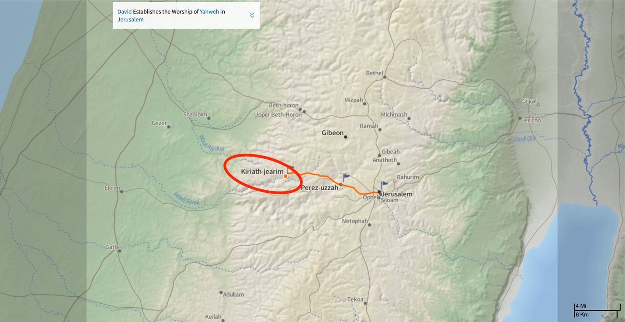
      - In the time of the judges this village was one of the four cities of the Gibeonites who, under false pretenses, made a mutual defense pact with Joshua and the elders of Israel (Jos 9:3–27).
      - Because it was on the border between Judah and Benjamin, it was integrated into the tribe of Judah (Jos 15:9; 18:14).
      - During the time of Samuel, after the Philistines captured the ark (1 Sm 4:11) and found its possession to be dangerous, they were advised to return it to Israel. This they did; the ark arrived in Bethshemish, where 70 men who peered into it perished. Because of the danger its presence presented, it was sent on to Kiriath-jearim, where it remained in “the house of Abinadab on the hill” (1 Sm 7:1) for 20 years.
      - One of King David’s first official acts after arriving in Jerusalem was to bring the ark from Baalah (Kiriath-jearim) to Obed-edom’s house, then on to Jerusalem (2 Sm 6).
      - Elwell, W. A., & Beitzel, B. J. (1988). Kiriath-jearim. In Baker encyclopedia of the Bible (Vol. 2, p. 1288). Grand Rapids, MI: Baker Book House.
      - After they mustered their forces, they marched to the house of Micah.
¹⁴ Then the five men who had gone to scout out the country of Laish said to their brothers, “Do you know that in these houses there are an ephod, household gods, a carved image, and a metal image? Now therefore consider what you will do.” ¹⁵ And they turned aside there and came to the house of the young Levite, at the home of Micah, and asked him about his welfare. ¹⁶ Now the 600 men of the Danites, armed with their weapons of war, stood by the entrance of the gate. ¹⁷ And the five men who had gone to scout out the land went up and entered and took the carved image, the ephod, the household gods, and the metal image, while the priest stood by the entrance of the gate with the 600 men armed with weapons of war. ¹⁸ And when these went into Micah’s house and took the carved image, the ephod, the household gods, and the metal image, the priest said to them, “What are you doing?” ¹⁹ And they said to him, “Keep quiet; put your hand on your mouth and come with us and be to us a father and a priest. Is it better for you to be priest to the house of one man, or to be priest to a tribe and clan in Israel?” ²⁰ And the priest’s heart was glad. He took the ephod and the household gods and the carved image and went along with the people.

      - These five men who had originally scouted the land, who had entered Micah’s home, met the priest, and sought his counsel for their exploits, reenter the home and begin to take the objects of worship (ephod and idol – though here it makes the carved image and the metal image appear distinct where before we saw them as one)
      - The priest asks them what they are doing and they tell him to be quiet and come.
      - They appeal to him by asking if it is better to be a priest over one person/family or over an entire clan.
      - The priest like this offer and willingly went with them to be a priest to the entire clan.
²¹ So they turned and departed, putting the little ones and the livestock and the goods in front of them. ²² When they had gone a distance from the home of Micah, the men who were in the houses near Micah’s house were called out, and they overtook the people of Dan. ²³ And they shouted to the people of Dan, who turned around and said to Micah, “What is the matter with you, that you come with such a company?” ²⁴ And he said, “You take my gods that I made and the priest, and go away, and what have I left? How then do you ask me, ‘What is the matter with you?’ ” ²⁵ And the people of Dan said to him, “Do not let your voice be heard among us, lest angry fellows fall upon you, and you lose your life with the lives of your household.” ²⁶ Then the people of Dan went their way. And when Micah saw that they were too strong for him, he turned and went back to his home.

The Holy Bible: English Standard Version. (2016). (Jdg 18:11–26). Wheaton, IL: Crossway Bibles.

      - Micah discovers what has happened and sets out in pursuit.
      - He asks why they have taken his idols and his priest.
        - Consider his response….he is bemoaning the theft of God’s who HE made and who are supposed to protect HIM but could not even protect THEMSELVES.
        - This is irony and sadness.
        - When we put our faith in a false God, we have no security.
        - When you have to protect your gods rather then they protecting you, you might want to consider whether that God is worthy of your worship.
      - Their only response, you might want to be quiet lest some angry fellows from among us fall up on you and kill you.
      - Dan proceeds on an Micah, realizing he has lost, goes home.
      - Again, we see people doing what is right in their own eyes.
      - Not only did Micah invent his own religion and make his own gods, now Dan is taking land that was not allotted to them, stealing idols and people that is not theirs to take, and doing what is right in their own eyes.
      - They proceed on.
    - Dan’s City – 18:27-31
²⁷ But the people of Dan took what Micah had made, and the priest who belonged to him, and they came to Laish, to a people quiet and unsuspecting, and struck them with the edge of the sword and burned the city with fire. ²⁸ And there was no deliverer because it was far from Sidon, and they had no dealings with anyone. It was in the valley that belongs to Beth-rehob. Then they rebuilt the city and lived in it. ²⁹ And they named the city Dan, after the name of Dan their ancestor, who was born to Israel; but the name of the city was Laish at the first. ³⁰ And the people of Dan set up the carved image for themselves, and Jonathan the son of Gershom, son of Moses, and his sons were priests to the tribe of the Danites until the day of the captivity of the land. ³¹ So they set up Micah’s carved image that he made, as long as the house of God was at Shiloh.
The Holy Bible: English Standard Version. (2016). (Jdg 18:27–31). Wheaton, IL: Crossway Bibles.
    - The Danites invade Laish, a quiet and unsuspecting people. They slaughtered the city.
    - They must have been a people originally from Sidon
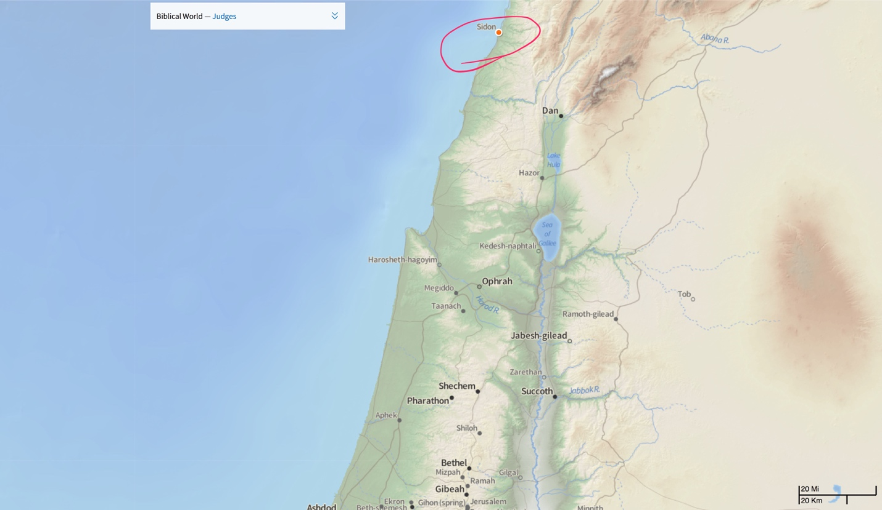
    - Since it references that there was no redeemer or deliverer from there to save them.
    - In this, we see Dan, a tribe who won’t take the land God allotted to them and instead we see a tribe that is willing to destroy a weak, defenseless, and unsuspecting tribe.
    - From here, we will move into seeing their complete immorality and eventual civil war in which all the tribes unite to destroy Benjamin.

  - Immorality (19)
  - Civil war (20–21)

Conclusion:

We are created to worship…so worship…God.
Application:

- No King in those days…they each did what was right in their own eyes.
  - We will see this statement several more times between here and the end of the book (or at least parts of this sentence)
  - Results in apathy, apostasy, and anarchy.
  - We see a young man stealing from his own mother.
  - We see her cursing whoever took it.
  - We see him return it only to have it shaped in the form of an idol, in the name of Yahweh
  - We see this young man create his own religion and worship
  - We see a Levite out of territory, accepting a job to be the priest for a single family.
  - We see the tribe of Dan looking for a different allotment of land because they failed to take theirs.
  - We see this same tribe stealing Micah’s household gods and goods, not to destroy them, but to set them up as their own TO WORSHIP.
  - We see this same people group destroy an entire village and make it their home when it was a land not given to them.
  - They each did what was right in their own eyes.
APPLICATION:
  - When we do what is right in our own eyes…we have no moral compass to guide us.
  - When we ignore the truth of God’s word in favor of what we want, the results are catastrophic.
  - When we are not actively worshiping God, loving God, pursing God, we will fall back to that which is most natural for us…ourselves. When we fail to worship God, we will worship ourselves instead.
  - We will devise something to worship.
- Crafted their own religion.
  - Why would Micah have felt compelled to do so if he were worshipping and serving God properly?
    - If we being truly and fully satisfied in God alone, we have no need to go elsewhere.
    - The fact that they turned to other gods reveals that they were not satisfied in God alone
    - This is why John Piper’s statement – God is most glorified in us when we are most satisfied in Him – hold such significance for me.
    - It is the same reason why I find his statement about temptation so profound…He states (and I paraphrase) that the key for overcoming temptation is finding superior satisfaction in God alone.
    - BECAUSE if we are satisfied in God alone, if we are delighting ourselves in Him, we will not be lured and enticed elsewhere because we have already found our delight in Him.
    - Micah crafted his own religion because God wasn’t doing it for him.
    - May that never be true of us. May we never be tempted to stray because we are being completely satisfied in God alone.
  - What does it say about the heart of man that Micah, when he failed to find his satisfaction in God, created his own?
    - We were created to worship.
    - We were created to worship…God. When we allow that natural inclination of worship to get directed elsewhere, that is when we develop problems. We are created to worship. That worship should just be directed towards God.
  - We see the tribe of Dan STEALING another man’s gods and priests to take and worship them as their own.
  - We see in the heart of these people a desire to worship. Problem is, they are worshipping the wrong thing in the in the wrong way.
  - We are created to worship. God is supposed to be the object and fulfillment of that worship and, for Israel as well as for us, we often place something else where God is supposed to be.

The lesson we need to learn his simply this…Be satisfied in God.

I feel like I say that a lot but then again, that is the theme of scripture isn’t it?
Be satisfied in Him and you will not find yourself being drawn to other things.
Surround yourself with people that will fill you motivation and encouragement to be growing in Christ.
Minimize the influences in your life that would pull you away from God.
You were made to worship…so worship…God.
And as you worship him, you will find yourself growing together to become more like Jesus for the glory of God.

